TASK 1:
public class PrintName {
public static void main(String[] args) {
String name = "GREETINGS"; // Replace "Your Name" with your actual name
System.out.println(name);
}
}

TASK 2:
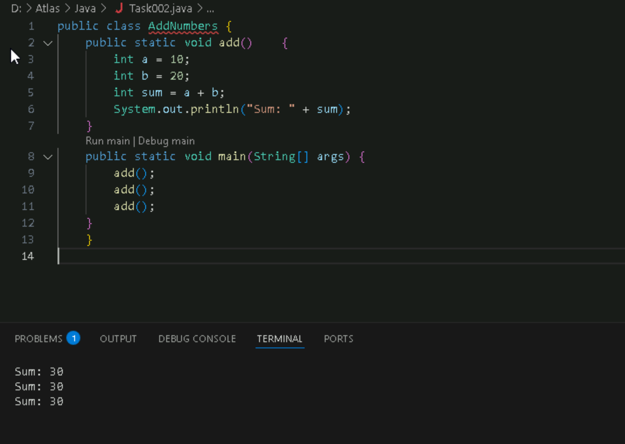
Task3:
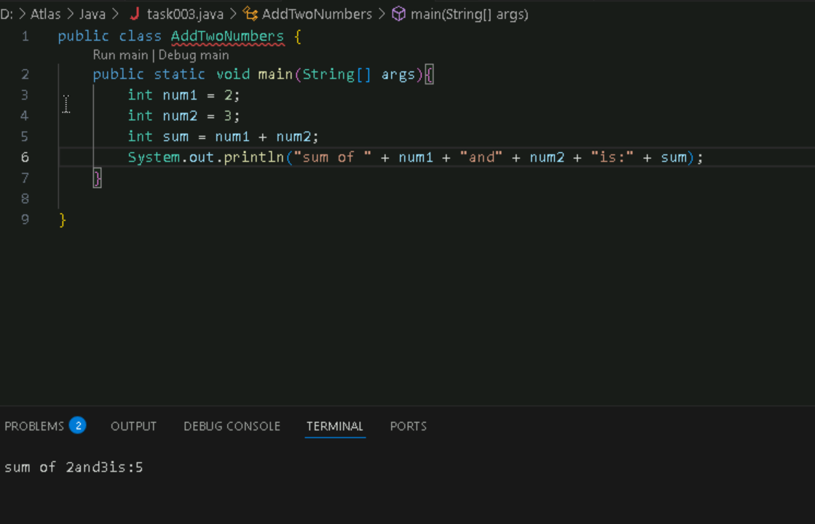
Task 4:
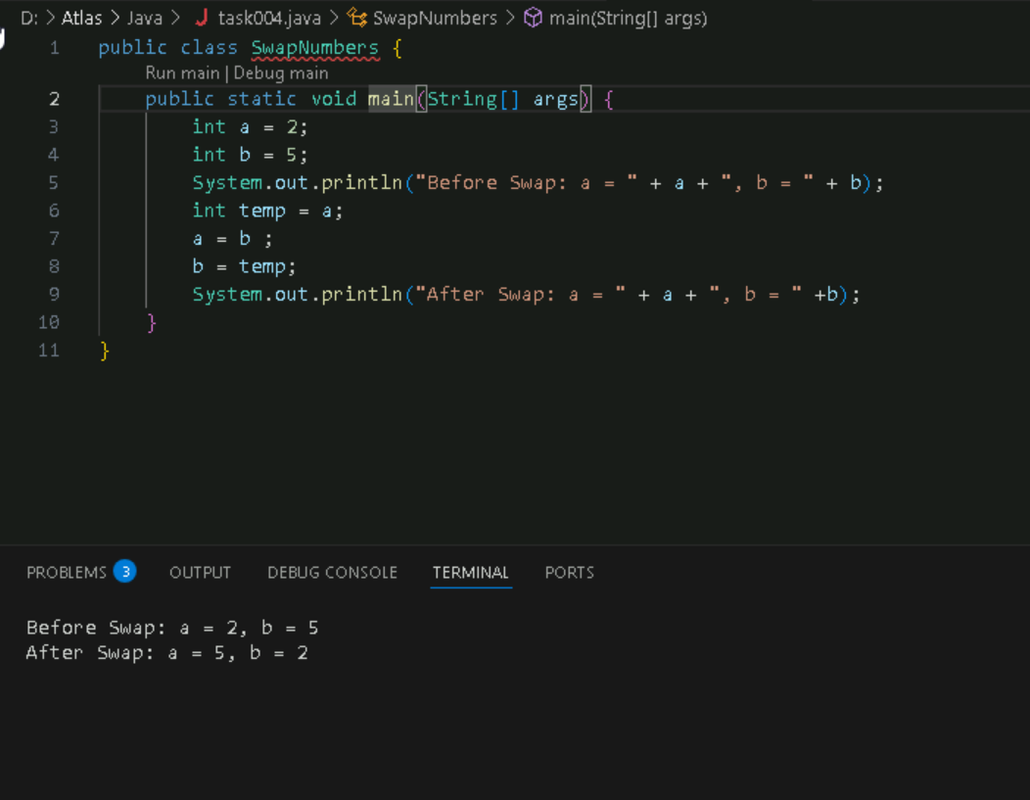
Task 5:
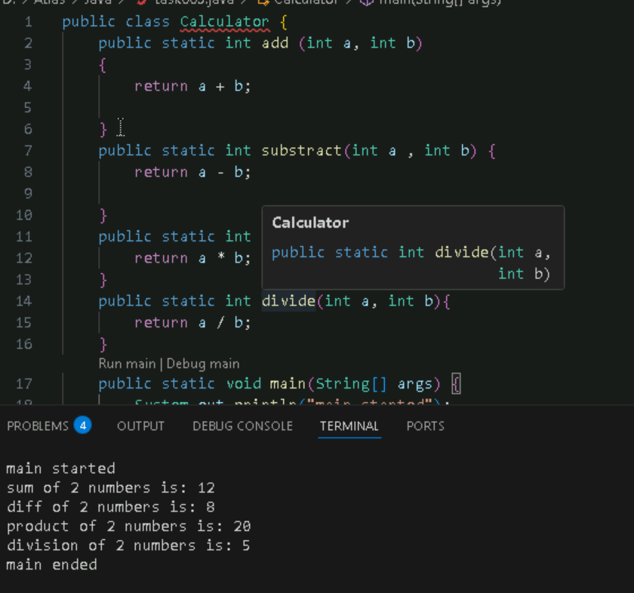
Task 6:
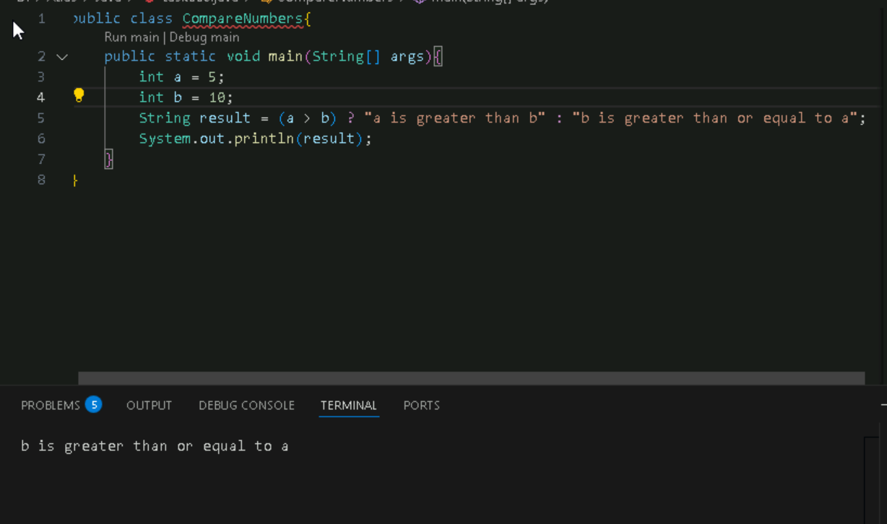
Task7:
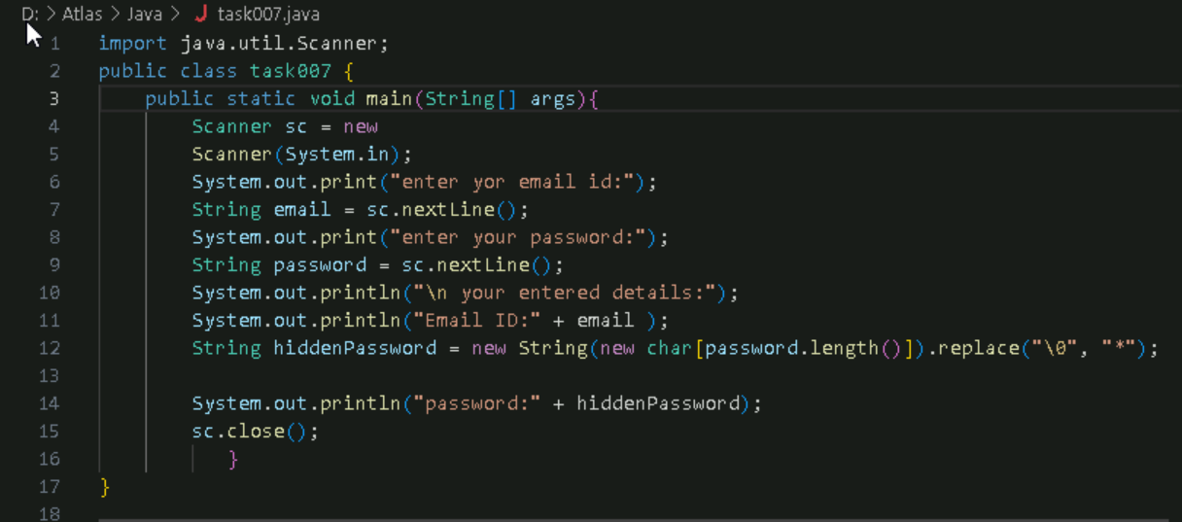
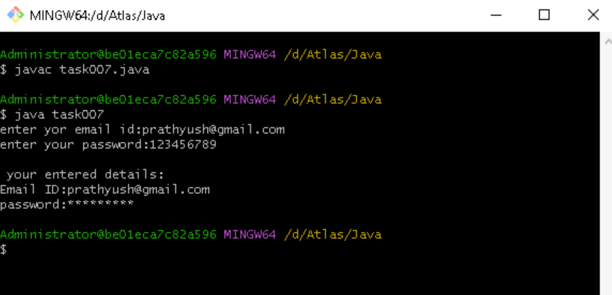
Task 8:
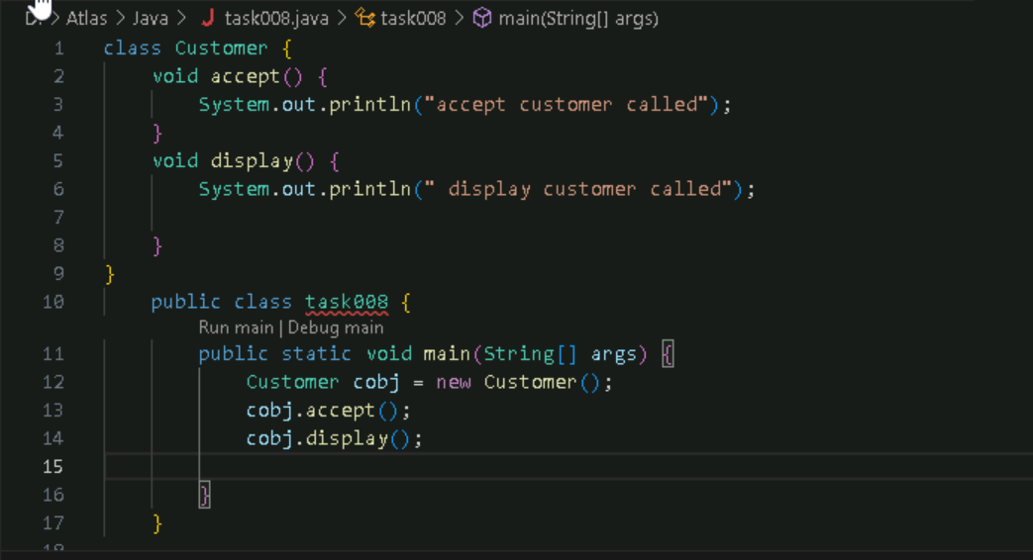

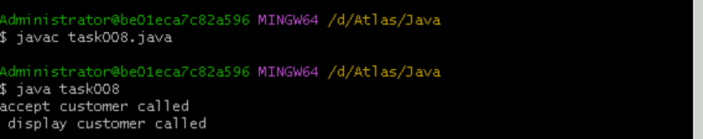
Task 9:
Task009:

Wap to check the greater of 2 numbers

Hint:
Use if else

If ( num1 > num2){
sout(“num1 is greater”);
}
Else {
sout(“num2 is greater”);
}

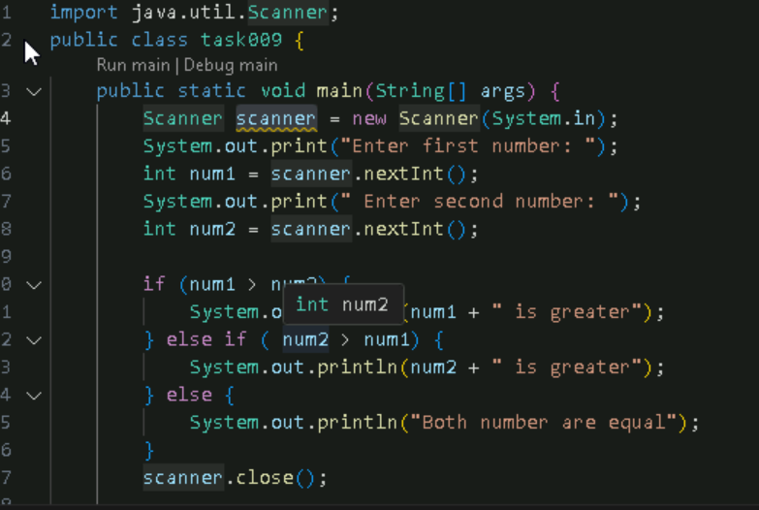
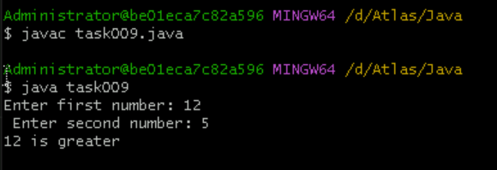
Task 10:
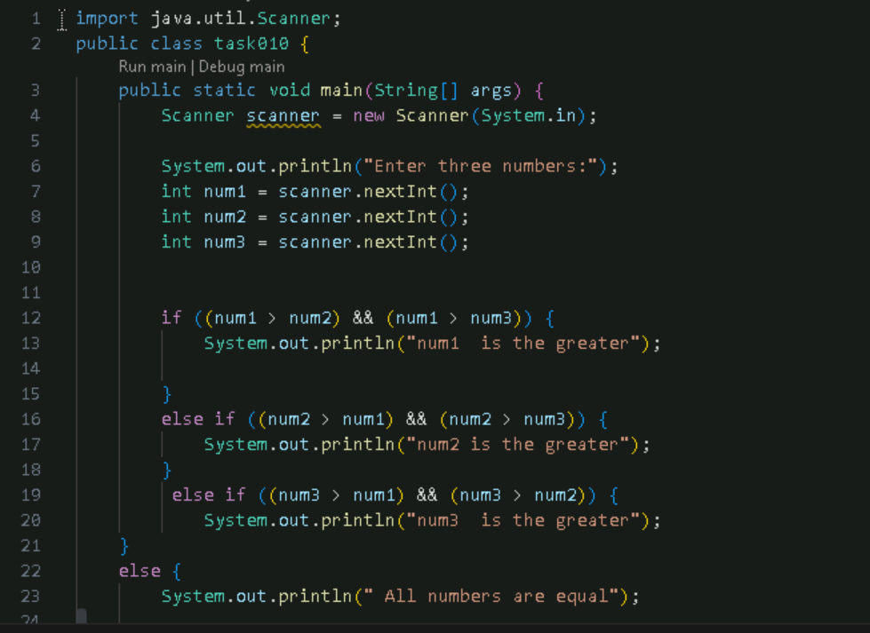
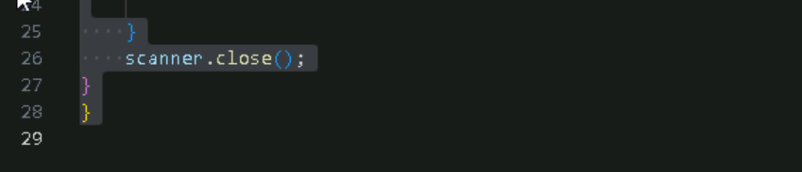
Output:
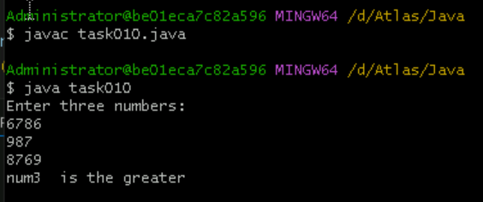

Task 11:
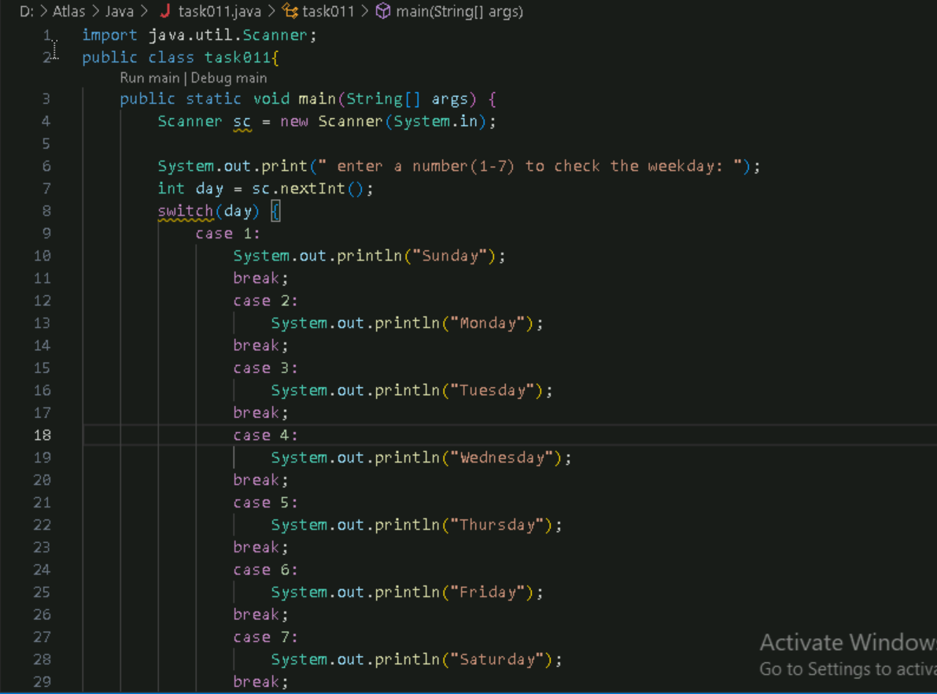
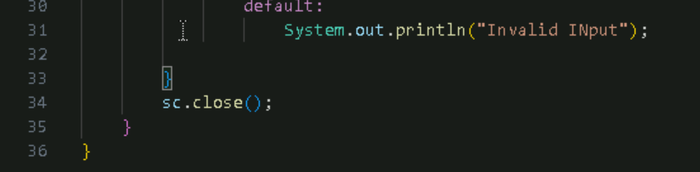
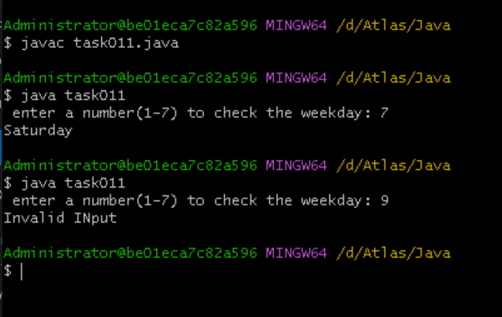

Task 012

Wap to check loginid and password validation

Hint use while loop

Scanner sc = new Scanner(System.in);

String loginid = “Prasunamba”
String pwd = “12345867”
Int Count = 0;

While (loginid == “Prasunamba” && pwd == “12345867”){
sout(“ you have logged in for ”+ count++ +” times”);
sout(“enter ur login id and password”);
loginid = sc.NextLine();
pwd = sc.NextLine();
}
Do while also use 👍

Scanner sc = new Scanner(System.in);

String loginid = “Prasunamba”
String pwd = “12345867”
Int Count = 0;

do{
sout(“ you have logged in for ”+ count++ +” times”);
sout(“enter ur login id and password”);
loginid = sc.NextLine();
pwd = sc.NextLine();
}While (loginid == “Prasunamba” && pwd == “12345867”);
sc.close();

While and do while loops - indefinite loops
For loop is definite…
For (initialization exp; condition exp; incre or decre exp)
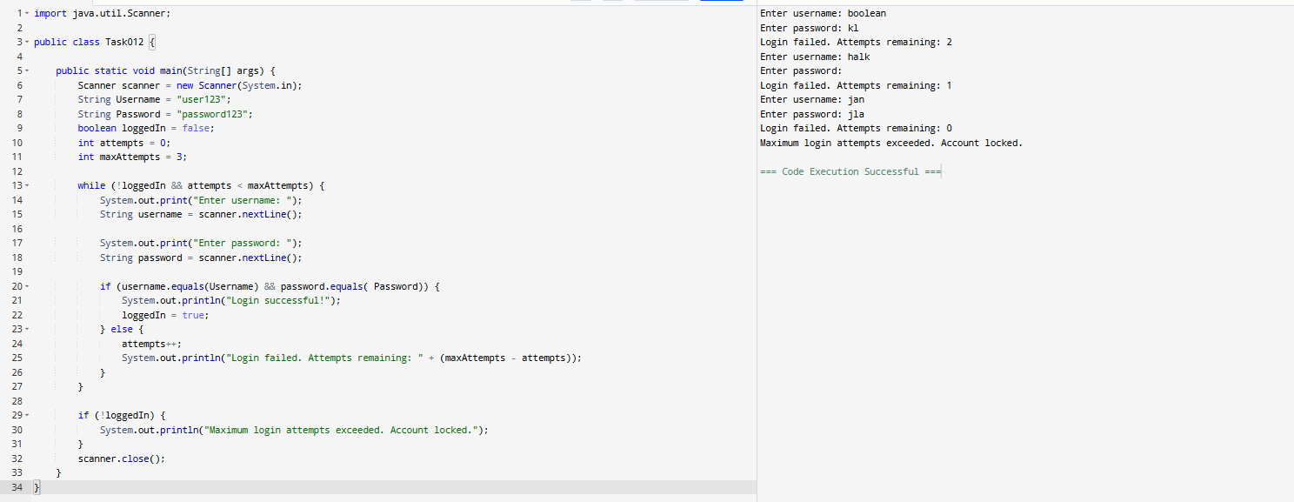

Task 13:

Wap to display numbers from 10 to 1 .. skip 7 and 5.

for(int i= 10; i >0; i–){
If ( i == 5 || i == 7)
Continue;
sout(i);
}

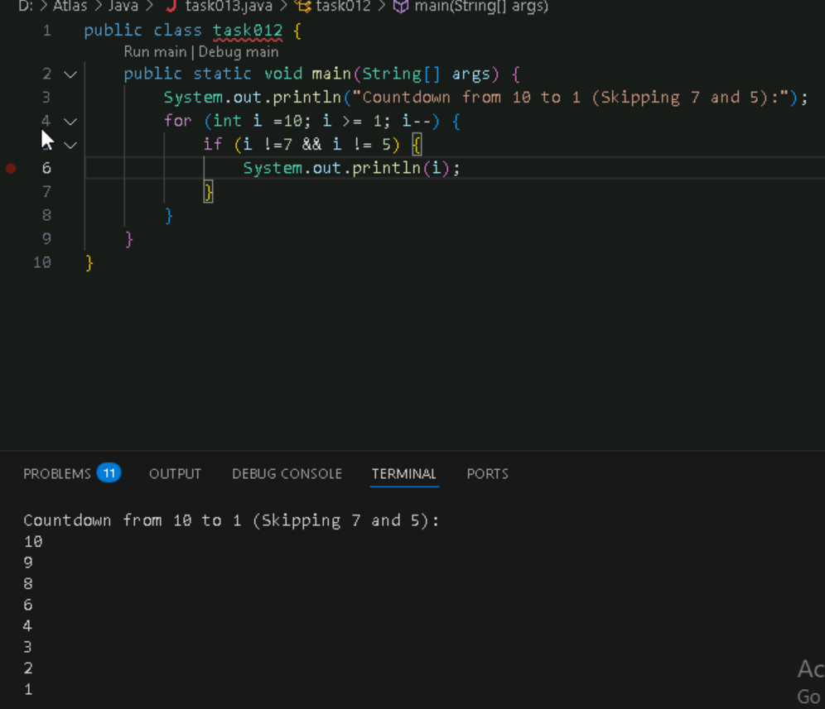
Task 14:

Arrays:

Try the below code and display the output…
Now play with it try to access arr of 5th index and see the output…and try to access arr of -1 index and see the output..

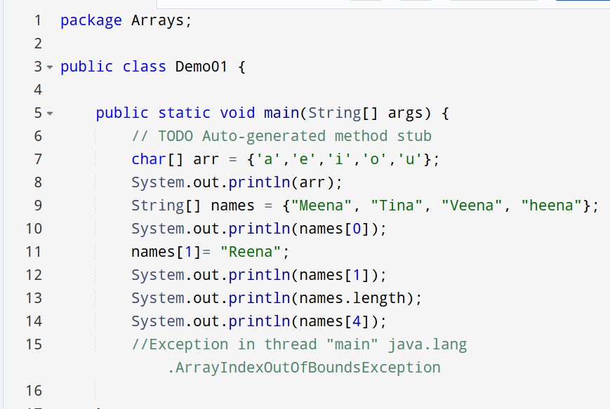
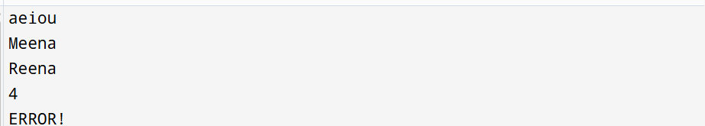
Task15:
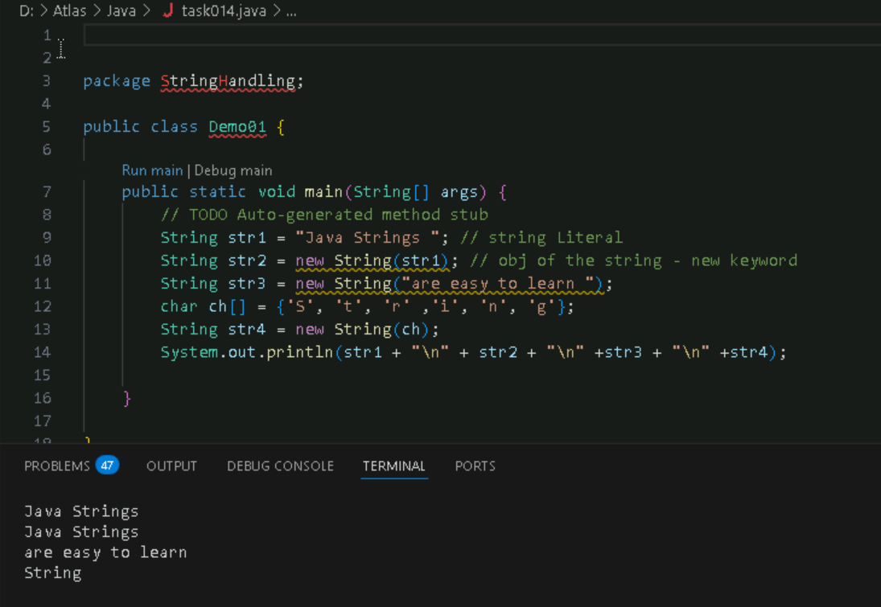
Task16:

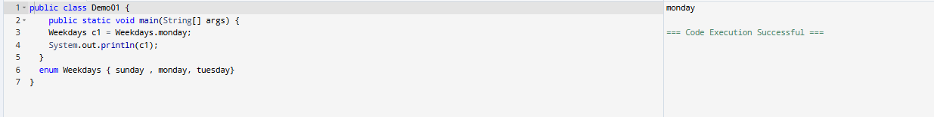

Task 17 task 18:

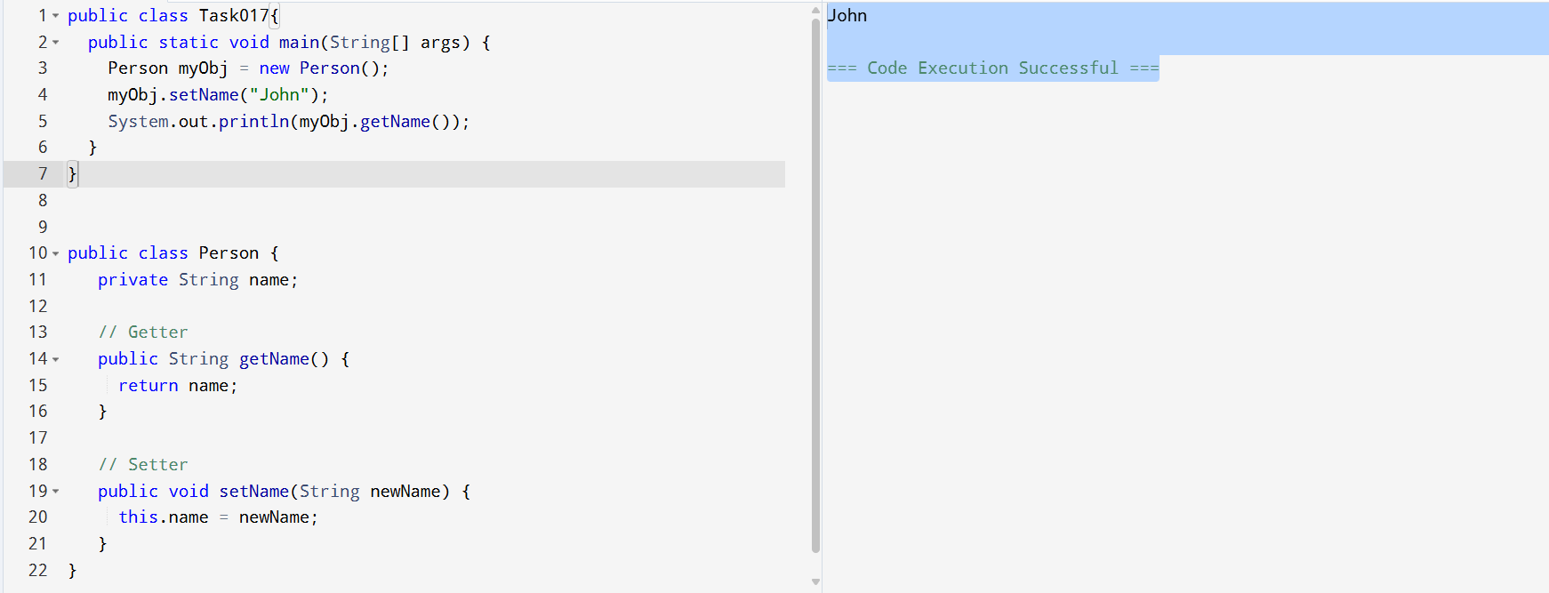
Task 20:
